**VirtIO Input**

1. **背景概要**

在 Vela 上实现了基于 [VirtIO 1.2标准](https://docs.oasis-open.org/virtio/virtio/v1.2/cs01/virtio-v1.2-cs01.html#x1-3650007)的通过 MMIO 通信的 VirtIO-Input 驱动，实现将 input 设备的事件发送到 Vela 上的功能。

2. **框架结构**

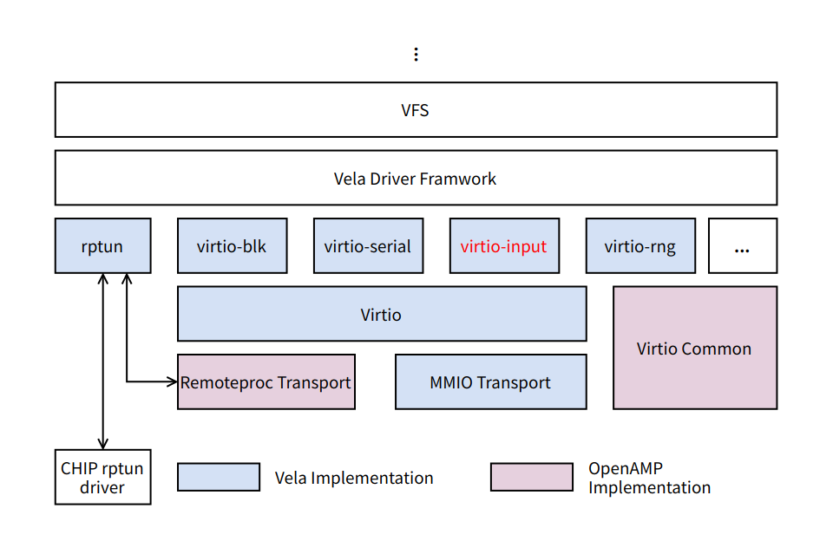

上图为 Vela Virtio 框架图，大致可以分为三部分：

1. 驱动层：将 virtio 和 Vela 驱动框架进行对接，驱动层调用 virtio 提供的统一接口进行设备的初始化和数据的交互；
2. Virtio 层：提供统一的接口给 Driver，实现 Driver/Device的注册，卸载和匹配机制；
3. 传输层：提供不同传输层的支持；

3. **实现细节**

3.1 **工作流程**

3.1.1 **初始化与注册**

1. virtio_register_input_driver - 注册g_virtio_input_driver
2. virtio_input_probe和virtio_input_remove - 由 VirtIO 框架调用，实际的初始化/移除入口
3. 在 virtio_input_probe中注册事件回调函数 virtio_input_recv_events，并且按照设备的类型(鼠标、键盘、touchpad)，注册 Vela input 驱动

3.1.2 **接收 virtio input 事件**

virtio_input_recv_events 来自一个中断，在这里创建异步工作队列 virtio_work_queue 进行 input 事件处理。

3.1.3 **向 Vela 发送 input 事件**

在异步工作队列 virtio_work_queue 的 virtio_input_worker 函数中，使用 virtqueue_get_buffer 读取 input 事件，然后根据设备的类型(鼠标、键盘、touchpad)，使用 virtio_send_keyboard_event virtio_send_mouse_event virtio_send_touch_event 发送到 Vela 中。

3.2 **数据结构**

|  |
| --- |
| C struct virtio_input_event {  uint16_t type;  uint16_t code;  uint32_t value; }  typedef void (*virtio_send_event_handler)(struct virtio_input_priv *,  struct virtio_input_event *);  struct virtio_input_priv {  FAR struct virtio_device *vdev;  char name[NAME_MAX]; /* Device name */  struct virtio_input_event evt[VIRTIO_INPUT_EVT_NUM];  size_t evtnum; /* Input event number */  struct work_s work; /* Supports the interrupt handling "bottom half" */  virtio_send_event_handler eventhandler;   union  {  struct mouse_lowerhalf_s mouselower; /* Mouse device lowerhalf instance */  struct keyboard_lowerhalf_s keyboardlower; /* Keyboard device lowerhalf instance */  struct touch_lowerhalf_s touchlower; /* Touchpad device lowerhalf instance */  };   union  {  struct mouse_report_s mousesample; /* Mouse event */  struct keyboard_event_s keyboardsample; /* Keyboard event */  struct touch_sample_s touchsample; /* Touchpad event */  }; }; |

3.3 **重点函数**

3.3.1 **virtio_register_input_driver**

|  |
| --- |
| C static struct virtio_driver g_virtio_input_driver = {  .node = LIST_INITIAL_VALUE(g_virtio_input_driver.node), /* node */  .device = VIRTIO_ID_INPUT, /* device id */  .probe = virtio_input_probe, /* probe */  .remove = virtio_input_remove, /* remove */ };  int virtio_register_input_driver(void) {  return virtio_register_driver(&g_virtio_input_driver); } |

3.3.2 **virtio_input_probe**

|  |
| --- |
| C static int virtio_input_probe(FAR struct virtio_device *vdev) {  FAR struct virtio_input_priv *priv;  FAR const char *vqnames[VIRTIO_INPUT_NUM];  vq_callback callbacks[VIRTIO_INPUT_NUM];  int ret;   priv = kmm_zalloc(sizeof(*priv));  if (priv == NULL)  {  vrterr("No enough memory\n");  return -ENOMEM;  }   priv->vdev = vdev;  vdev->priv = priv;   /* Initialize the virtio device */   virtio_set_status(vdev, VIRTIO_CONFIG_STATUS_DRIVER);  virtio_set_features(vdev, 0);  virtio_set_status(vdev, VIRTIO_CONFIG_FEATURES_OK);   vqnames[VIRTIO_INPUT_EVENT] = "virtio_input_event";  callbacks[VIRTIO_INPUT_EVENT] = virtio_input_recv_events;  ret = virtio_create_virtqueues(vdev, 0, VIRTIO_INPUT_NUM, vqnames,  callbacks);  if (ret < 0)  {  vrterr("virtio_device_create_virtqueue failed, ret=%d\n", ret);  virtio_reset_device(vdev);  kmm_free(priv);  return ret;  }   virtio_set_status(vdev, VIRTIO_CONFIG_STATUS_DRIVER_OK);  virtqueue_enable_cb(vdev->vrings_info[VIRTIO_INPUT_EVENT].vq);  priv->evtnum = MIN(vdev->vrings_info[VIRTIO_INPUT_EVENT].info.num_descs,  VIRTIO_INPUT_EVT_NUM);   /* register lower half drivers */   virtio_input_register(priv);   virtio_input_fill_event(priv);   return ret; } |

3.3.3 **virtio_input_remove**

|  |
| --- |
| C static void virtio_input_remove(FAR struct virtio_device *vdev) {  FAR struct virtio_input_priv *priv = vdev->priv;   if (priv->eventhandler == virtio_input_send_keyboard_event)  {  keyboard_unregister(&(priv->keyboardlower), priv->name);  }  else if (priv->eventhandler == virtio_input_send_mouse_event)  {  mouse_unregister(&(priv->mouselower), priv->name);  }  else if (priv->eventhandler == virtio_input_send_touch_event)  {  touch_unregister(&(priv->touchlower), priv->name);  }   virtio_reset_device(vdev);  virtio_delete_virtqueues(vdev);  kmm_free(priv); } |

3.3.4 **virtio_input_register**

|  |
| --- |
| C static void virtio_input_register(FAR struct virtio_input_priv *priv) {  if (virtio_input_select_cfg(priv, VIRTIO_INPUT_CFG_EV_BITS, EV_ABS))  {  priv->touchlower.maxpoint = 1;  snprintf(priv->name, NAME_MAX, "/dev/virtinput%d",  g_virtio_touch_idx++);  touch_register(&(priv->touchlower),  priv->name,  priv->evtnum);  priv->eventhandler = virtio_input_send_touch_event;  }  else if (virtio_input_select_cfg(priv, VIRTIO_INPUT_CFG_EV_BITS, EV_REL))  {  snprintf(priv->name, NAME_MAX, "/dev/virtmouse%d",  g_virtio_mouse_idx++);  mouse_register(&(priv->mouselower),  priv->name,  priv->evtnum);  priv->eventhandler = virtio_input_send_mouse_event;  }  else if (virtio_input_select_cfg(priv, VIRTIO_INPUT_CFG_EV_BITS, EV_KEY))  {  snprintf(priv->name, NAME_MAX, "/dev/virtkbd%d",  g_virtio_keyboard_idx++);  keyboard_register(&(priv->keyboardlower),  priv->name,  priv->evtnum);  priv->eventhandler = virtio_input_send_keyboard_event;  } } |

3.3.5 **virtio_input_recv_events**

|  |
| --- |
| C static void virtio_input_recv_events(FAR struct virtqueue *vq) {  FAR struct virtio_input_priv *priv = vq->vq_dev->priv;  int ret;   ret = work_queue(HPWORK, &priv->work, virtio_input_worker, priv, 0);  if (ret != 0)  {  vrterr("ERROR: Failed to queue work: %d\n", ret);  }   return; } |

3.3.6 **virtio_input_worker**

|  |
| --- |
| C static void virtio_input_worker(FAR void *arg) {  FAR struct virtio_input_priv *priv = (FAR struct virtio_input_priv *)arg;  FAR struct virtqueue *vq = priv->vdev->vrings_info[VIRTIO_INPUT_EVENT].vq;  FAR struct virtio_input_event *evt;  FAR struct virtqueue_buf vb;  uint32_t len;   while ((evt = (FAR struct virtio_input_event *)  virtqueue_get_buffer(vq, &len, NULL)) != NULL)  {  vrtinfo("virtio_input_worker (type,code,value) - (%d,%d,%d).\n",  evt->type, evt->code, evt->value);   priv->eventhandler(priv, evt);   vb.buf = evt;  vb.len = len;  virtqueue_add_buffer(vq, &vb, 0, 1, vb.buf);  }   virtqueue_kick(vq); } |

3.3.7 **virtio_input_send_keyboard_event**

|  |
| --- |
| C static void virtio_input_send_keyboard_event(FAR struct virtio_input_priv *priv,  FAR struct virtio_input_event *event) {  if (event->type == EV_KEY)  {  priv->keyboardsample.code =  virtio_input_translate_keycode(event->code);  priv->keyboardsample.type = event->value;  }  else if (event->type == EV_SYN && event->code == SYN_REPORT)  {  keyboard_event(&(priv->keyboardlower),  priv->keyboardsample.code,  priv->keyboardsample.type);  memset(&priv->keyboardsample, 0, sizeof(priv->keyboardsample));  } } |

3.3.8 **virtio_input_send_mouse_event**

|  |
| --- |
| C static void virtio_input_send_mouse_event(FAR struct virtio_input_priv *priv,  FAR struct virtio_input_event *event) {  if (event->type == EV_REL)  {  switch (event->code)  {  case REL_X:  priv->mousesample.x = event->value;  break;   case REL_Y:  priv->mousesample.y = event->value;  break;   #ifdef CONFIG_INPUT_MOUSE_WHEEL  case REL_WHEEL:  priv->mousesample.wheel = event->value;  break;  #endif  }  }  else if (event->type == EV_KEY)  {  switch (event->code)  {  case BTN_LEFT:  if (event->value)  {  priv->mousesample.buttons |= MOUSE_BUTTON_1;  }  break;   case BTN_RIGHT:  if (event->value)  {  priv->mousesample.buttons |= MOUSE_BUTTON_2;  }  break;   case BTN_MIDDLE:  if (event->value)  {  priv->mousesample.buttons |= MOUSE_BUTTON_3;  }  break;  }  }  else if (event->type == EV_SYN && event->code == SYN_REPORT)  {  mouse_event(priv->mouselower.priv, &priv->mousesample);  memset(&priv->mousesample, 0, sizeof(priv->mousesample));  } } |

3.3.9 **virtio_input_send_touch_event**

|  |
| --- |
| C static void virtio_input_send_touch_event(FAR struct virtio_input_priv *priv,  FAR struct virtio_input_event *event) {  if (event->type == EV_ABS)  {  switch (event->code)  {  case ABS_PRESSURE:  priv->touchsample.point[0].flags |= TOUCH_PRESSURE_VALID;  priv->touchsample.point[0].pressure = event->value;  break;   case ABS_X:  priv->touchsample.point[0].flags |= TOUCH_POS_VALID;  priv->touchsample.point[0].x = event->value;  break;   case ABS_Y:  priv->touchsample.point[0].flags |= TOUCH_POS_VALID;  priv->touchsample.point[0].y = event->value;  break;  }  }  else if (event->type == EV_SYN && event->code == SYN_REPORT)  {  priv->touchsample.npoints = 1;  priv->touchsample.point[0].timestamp = touch_get_time();   touch_event(priv->touchlower.priv, &priv->touchsample);  memset(&priv->touchsample, 0, sizeof(priv->touchsample));  } } |

在QEMU上的配置和使用参考[Input](https://xiaomi.f.mioffice.cn/wiki/wikk4azzFG85ez1QjawKdgOQTsc)，rpmsg类似实现参考[Uinput](https://xiaomi.f.mioffice.cn/wiki/wikk4xILnAysSDLMya58pLdrtKg)，驱动架构参考[Input驱动](https://xiaomi.f.mioffice.cn/wiki/wikk401eCI9HXHJxQfmYhLRpmrf) 。